PRESS RELEASE | 12 July 2012

Web Pioneers Team Up For Tribute To 'Red Shirts'

Two internet pioneers are teaming up to make a video celebrating the heroes of pre-credits sequences.

'Don't, Darren, Don't' salutes the characters who always seem to die in the first few minutes of action films by walking into haunted basements, diving into shark infested waters or just wearing red shirts in Star Trek.

It was recorded by MJ Hibbett & The Validators, the band who released the first ever internet single 'Hey Hey 16K' in 1994. The illustrations were created by John Allison, whose long running series of webcomics began in 1998 and whose latest work, 'Bad Machinery', is soon to be published in book form by Oni Press.

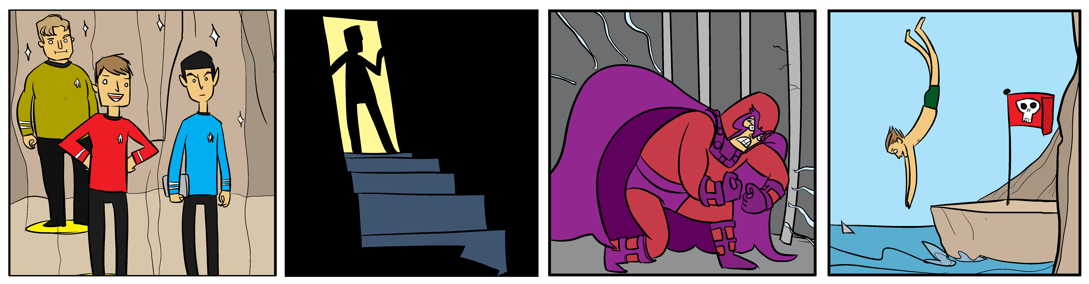
scenes from the video

John also designed the artwork for 'Dinosaur Planet', the original album from which 'Don't, Darren, Don't' is taken. It's a full-cast science fiction rock opera concept album which has been called "Jeff Wayne's new competition" by SFX, "the space dinosaurs vs. giant robots rock opera you've been waiting for" by io9 and "The Greatest Story (About Space-Faring Dinosaurs) Ever Told (In a Rock Opera)" by Comics Alliance.

The song features several guest stars including indie legend Phil Wilson (lead singer in the June Brides) and Steve Hewitt, who co-starred with MJ Hibbett in the original two-man Edinburgh Fringe show, which the album is based upon. Steve and MJ are reviving this version in August for appearances at the Camden Fringe and Green Man Festival.

The video comes with a free download mp3, available from 16 July until the end of August from http://www.dinosaurplanet.co.uk/darren . It will be launched with two MJ Hibbett & The Validators gigs, in London on 21 July and then headlining the Red House stage at the Tramlines festival in Sheffield on 22 July.

For more information contact MJ Hibbett at mjhibbett@gmail.com
continues overleaf...
Launch Gigs
Saturday 21 July - Bloomsbury Bowling Lanes, London WC1H 9EU
appearing as part of the PopArt 'End Of An Earache' festival, on stage 7pm.
Sunday 22 July - The Red House, Sheffield S1 4BB
headline set at the Tramlines Festival, on stage 10pm.

Background
MJ Hibbett & The Validators have performed live on Radio One, had a Record Of The Year in Rolling Stone, an Album Of The Day on 6Music, toured all around the world and very narrowly avoided writing an autobiography. They're probably best known for 'Hey Hey 16K', the world's first ever internet viral hit.
John Allison is a pioneer of webcomics, having started 'Bobbins' in 1998 and 'Scary Go Round' in 2002. There have been five 'Bad Machinery' stories so far, each exceeding 100 pages. The first Oni Press volume will collect 'The Case of the Team Spirit', a story revolving around a haunting within the local football club. This full-colour paperback is scheduled for March of next year.
'Don't, Darren, Don't' features guest appearances by Phil Wilson, Jenny Lockyer, Steve Hewitt and Jonny Yeah as the narrator.

www.dinosaurplanet.co.uk/darren

